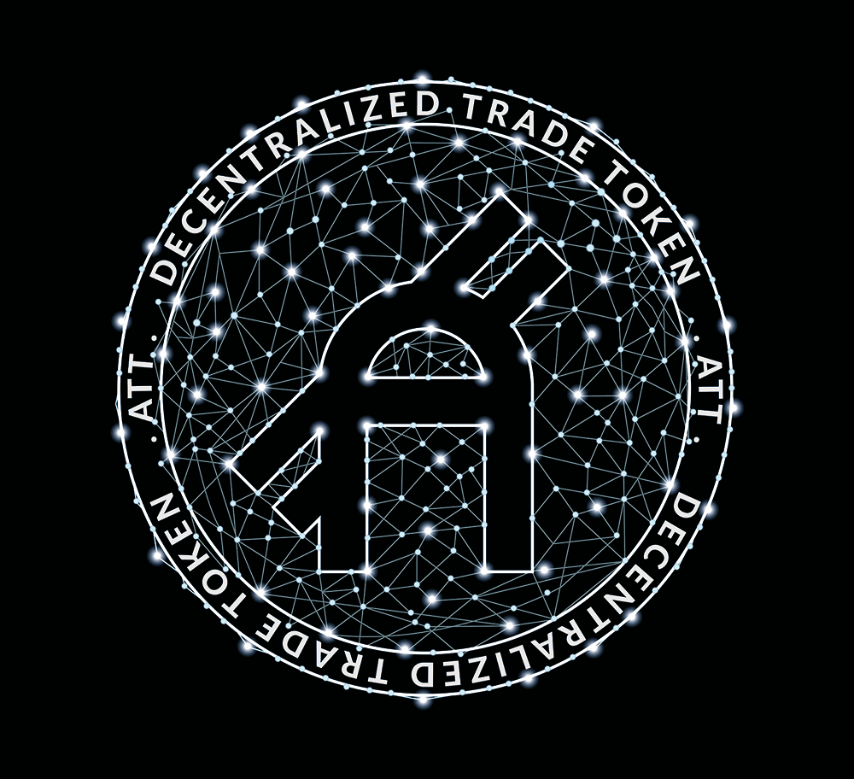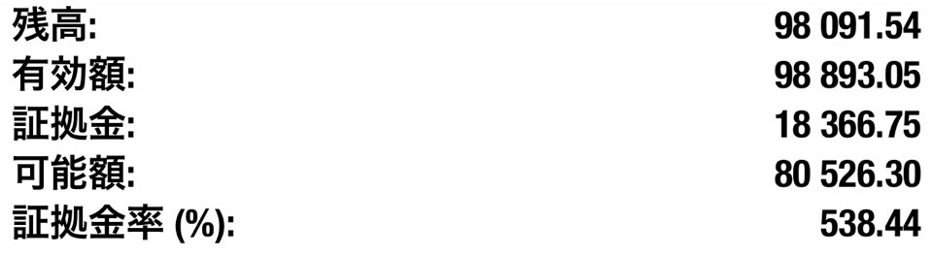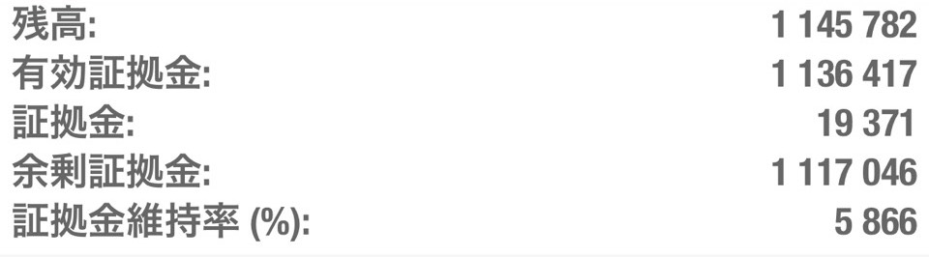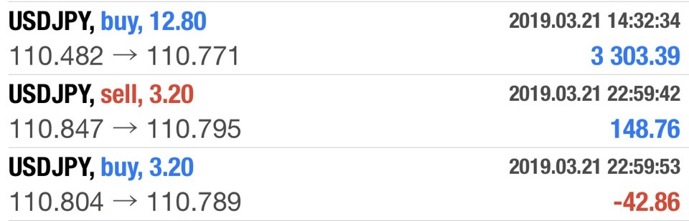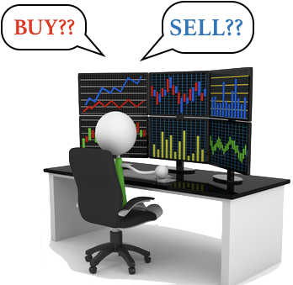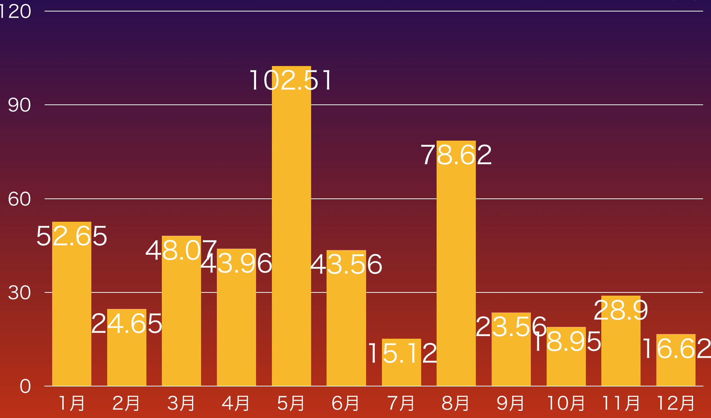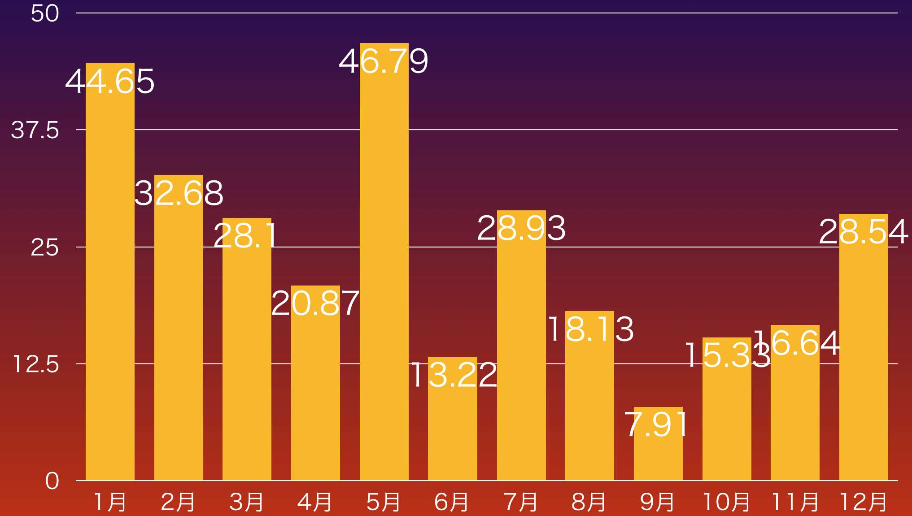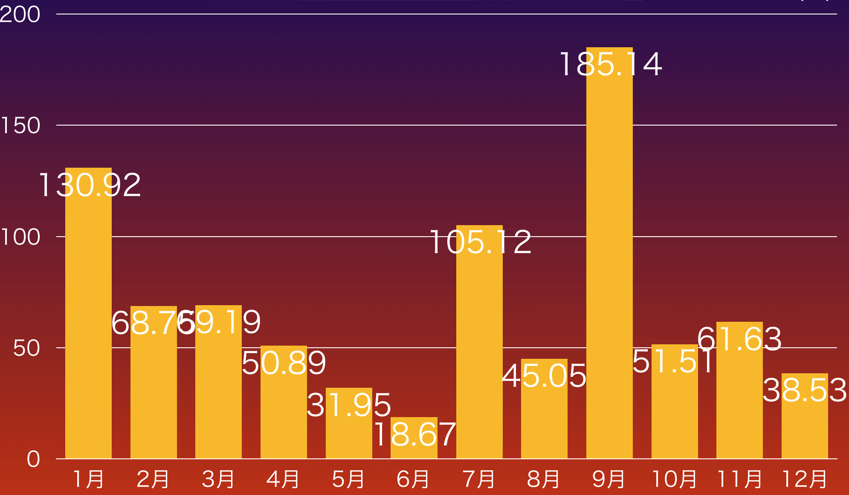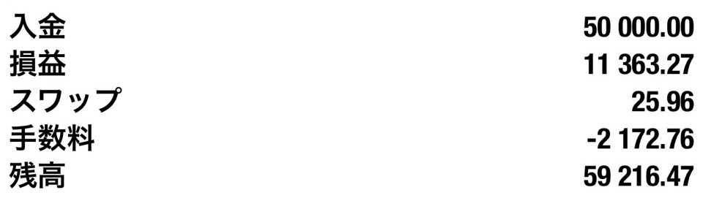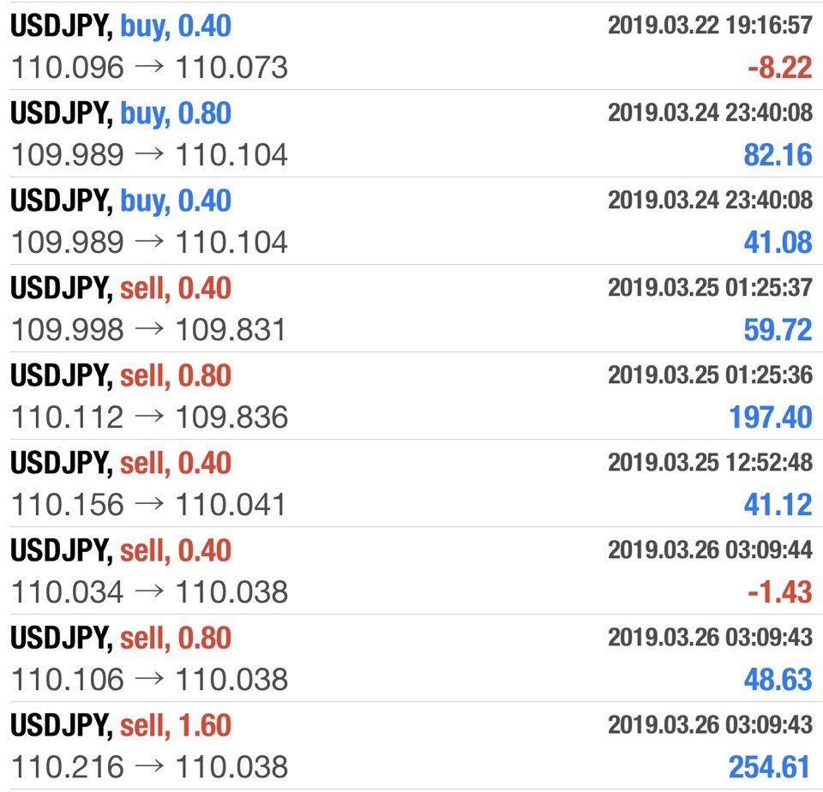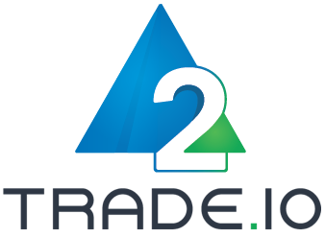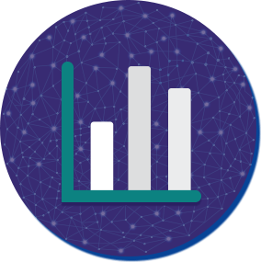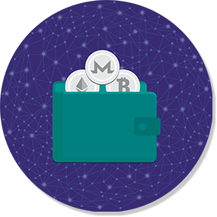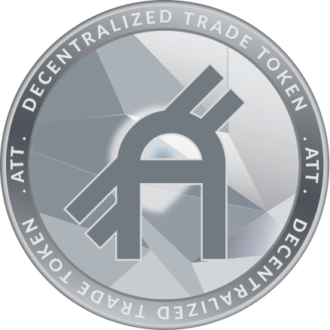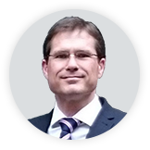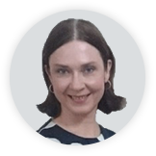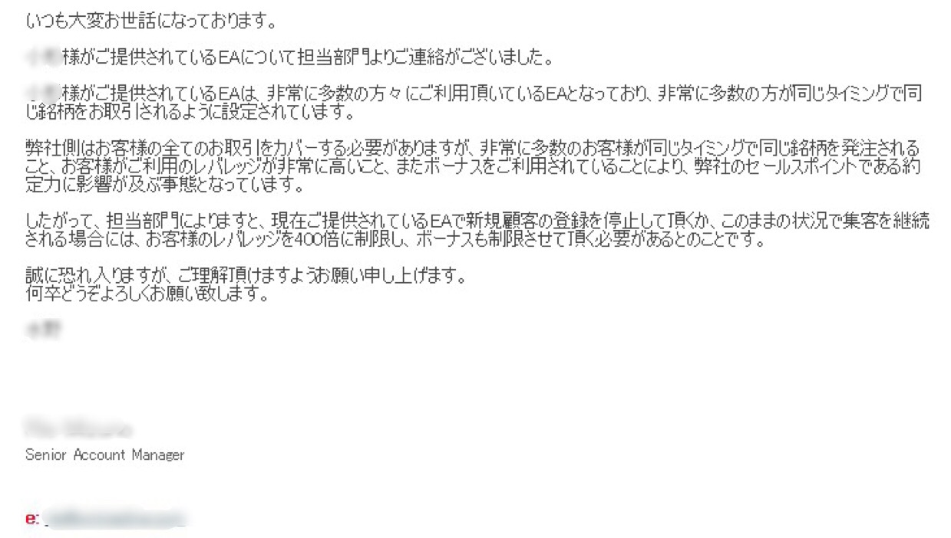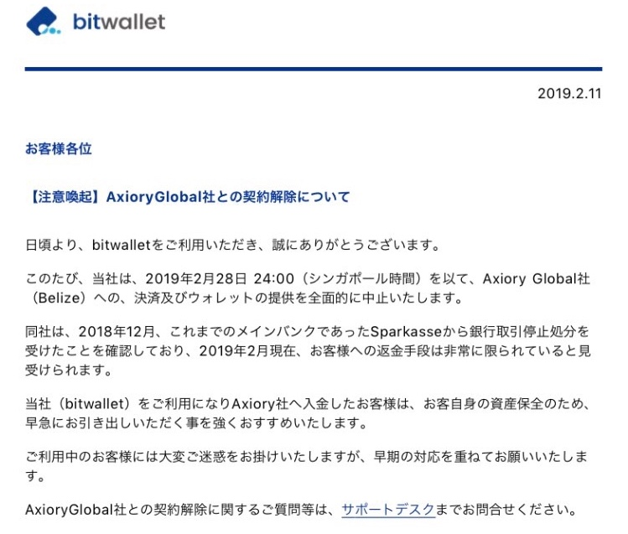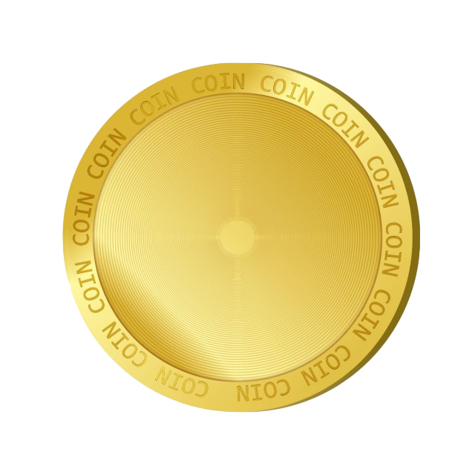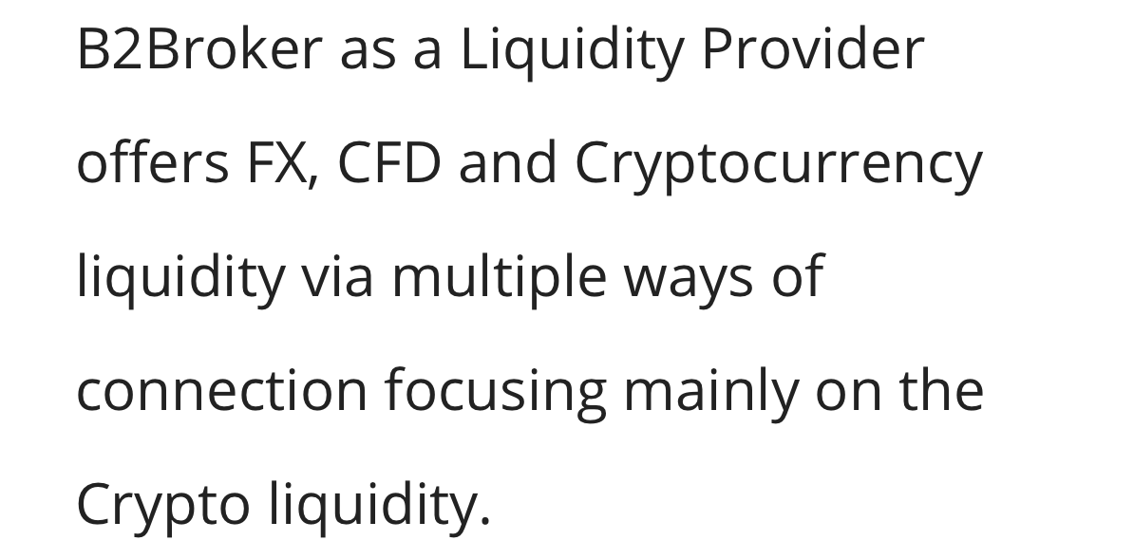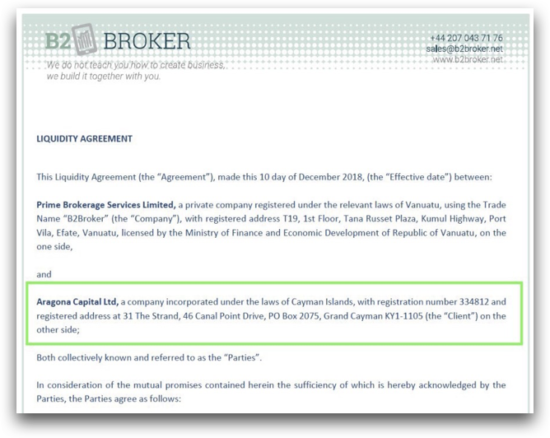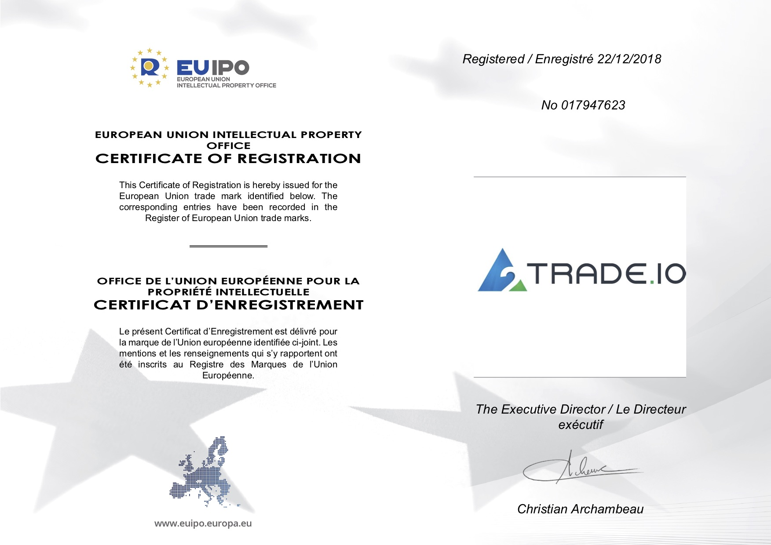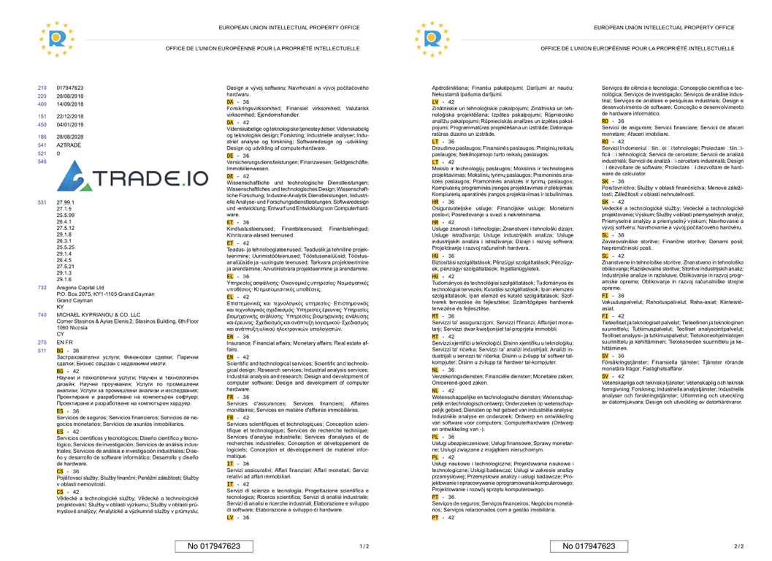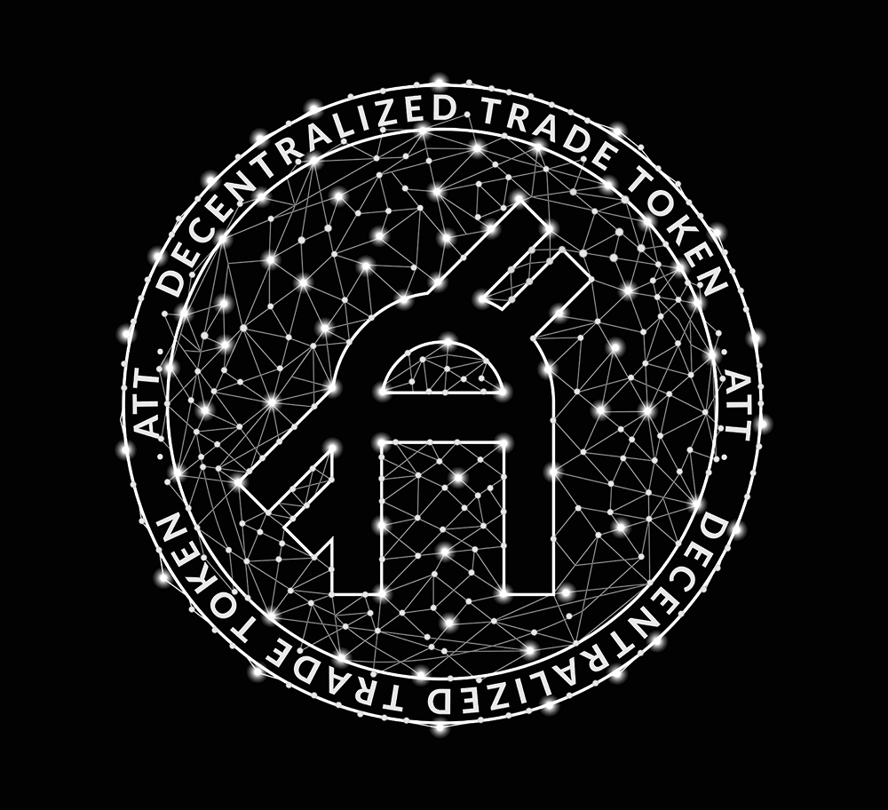

**ICO ×FX**

**Materials**

Trading using about 1/5 of the funds

Trading using about 1/50 of the funds

**Margin Level**

The **Forex margin level** is the percentage value based on the amount of accessible usable **margin.**

* The red circle is the number of lots

Traders need to set trading volume up per an account as Lot.

1 Lot = 100,000 Currencies

The risk of FX trading is determined by (1) how much currency (a. Lot) is handled in one trading. (2) Balance of trading volume and margin (= all balance in an account) (b. Margin Level)

What is the risk of FX trading?

FX is a financial product that sells and buys currencies from all over the world and makes a profit with the price difference. There are two kinds to make a profit. The first is to **buy at a lower price, and selling it when it gets higher**. The second is to **sell at a high price, and buying back when it gets lower.**

What is FX（Foreign change）?

**Lot**

Ex1) BUY $1 (= \110.20)×100,000 currencies, SELL $1 (= \110.35)

　　(\110.35×100,000) – (\110.20×100,000) = \15,000 profit

Ex2) SELL $1 (= \110.20)×100,000 currencies, BUY $1 (= \110.10)

(\110.20×100,000) – (\110.10×100,000) = \10,000 profit

SELL

BUY

SELL

BUY

110.35

110.10

110.20

The figures listed in each of the graphs below are traded at a simple interest rate using the first payment amount. The reason why the figures for each year are different is due to the relationship between the AI method and the movement of the market. In addition, the fluctuation range of the chart of the day influences the size of the profit.

AI (USD/JPY) Performance for 3 years (monthly %)

AI (= Artificial Intelligence) is a fully automatic buying and selling system, which has positions according to several built-in trading strategy. We can trade at all times as the currency markets are running from Monday morning to Friday night. In addition, it is also possible to shut off the system when there is a dangerous market price with the discretionary trading.

What is AI?

2018

2017

2016

* Based on the above data, Forex's recommended deposit amount is calculated, and if the margin level is sufficiently secured, the minimum deposit amount is between **10K and 12K**. If you want to make a double profit on the basis of this amount, you need a deposit of 20K to 24K. If it is 10 times, it is 100K-120K.

**Supplementary explanation of analysis results**: USD / JPY has a trading range of about 0.9 to 1.1 yen on an average per day. In this AI, the maximum holding position is 10.11. In the trade holding 10.11 Lot, it is executed when the market price has already moved by 1.5 to 1.7 yen in either direction. Therefore, from the results of 5 above, it can be understood that the probability of occurrence of such a situation is quite low. Furthermore, this EA is made by back calculating from the point that the margin level when having 10.11 Lot is safe.

1. Total number of trading for 3 years from 2016 to 2018

**3**

**7 (0.17%)**

**1.5－1.7 JPY**

**10.11 Lot**

**0.9－1.1 JPY**

**4127**

6. Number of occurrences in 7 times due to *economic announcement

5. Number of times with 10.08 Lot in all trades

2. Daily Average Volatility of USD/JPY

3. Maximum number of holding lots (at same time)

4. Volatility from holding the first position to holding 10.11 lots

Risk Analysis of AI (USD / JPY)

* Economic announcements quantify the economic conditions of each country, and the

indicators in the US, Europe, the UK, Australia, and Japan may affect the market.

*This AI is a system that is likely to be able to gain profits little by little, avoiding high-risk trading.*

* You are entitled to this discount only if you

deposit for FX trading at least the same amount

as token purchases or more

|  |  |  |  |
| --- | --- | --- | --- |
| **Deposit for**  **Token ($)** | $5,000 | $10,000 | $25,000 |
| **Discount (%)** | 10% | 25% | 35% |
| **Fees with**  **discount ($)** | **-1955.48** | **-1629.57** | **-1412.29** |

**2．Trading**

**charges**

**1. Transaction**

**Agency fee**

*Ⅱ. Trading charges*

This is the fee that a broker takes to apply for a trader's order

to a bank. This is the profit of the broker.

* By purchasing a certain number of ATT tokens developed or provided by

A2TRADE, the trading fee can be saved and a large profit can be earned for a long

term.

How get profits more

Ex) USD/JPY

Ask : 110.851

Bid : 110.850

**Trader**

***Ⅰ.***  *Spread*

　The price difference when selling a currency (Bid) and the price

when buying a currency (Ask) in changing exchange rates

Two types of fees

**SEBASTIAN FORBES - FINANCIAL OFFICER**

**CFO for some of the largest offshore Forex trading companies, responsible for all aspects of financial accounting and reporting. Combines a strong background in financial markets products with an extensive knowledge of business support functions such as business development, financial, operations, risk and finance. Proactive and highly focused with strong investigative skills. Possess an analytical and logical approach to problem solving and adept at handling and interpreting data.**

**CHRIS MILINAZZO - PROJECT MANAGER**

**25+ years in software and systems development within the aerospace industry. Project management experience leading multimillion-dollar projects. An expert in leading teams to deliver business critical online products to domestic and international markets. Work experience including fortune l00 and 500 companies such as Raytheon, Goodrich and United Technologies. Early blockchain advocate and general technologist possess an analytical and logical approach to the problem solving and adept at completing projects on time and under budget.**

**TATIANA SHABANOVA - RISK MANAGER**

**Economist working in the financial and investing sectors for 28 years. Excellent knowledge of all commercial activities, in English, Greek and Russian. Establishing multi-national contacts at all levels (incl. Government Institutions). Exceptional communication skills and experienced in negotiations. Aug. l989 Moscow Financial University BSc. International Economic Relations.**

**Company**

* Operation of financial

instruments exchange

* System development

BUSINESS

Gladstonos M. Kyprianou House 3rd

and 4th floor Limassol Cyprus

LOCATION

Aragona Capital.Ltd

SYMBOL

**・Too many accounts and platforms**

**・Currency exchange takes time**

**・Lack of flexibility with accounts etc…**

Problems with existing brokers/exchange

**Provide a single platform for all your trading, investment and exchange needs**

A2TRADE is a hybrid broker / exchange that smoothly integrates fiat and virtual currency

payments on one platform. We utilize blockchain technology to support trade and exchange

stocks, bonds, indices, and CFD (Forex, Crypto currency, etc.). We will also support the exchange

for physical assets such as gold and diamonds.

**VISION**

Directors

Instance of Withdrawal Problem

**3 – 5 days**

Crypto withdrawal

The trading type B-Book has a relatively high leverage of the trading account. The broker manages client funds internally because it does not place orders with an agency that provides forex trading volume and price called LP. For that reason, broker needs to make clients lose as much as possible for the benefit of the company. Also, if profits more than expected are generated, broker secure company profits by freezing client accounts or refusing withdrawals.

Basically, the trading type of A-Book is internationally set to leverage of 200: 1. Broker that uses this type of trading actually places an order to an agency that provides forex trading volume and price called LP. The profits of broker depend on the volume of the client's trading, so by having the customer make a profit as much as possible and having the transaction continue, both sides become a win-win relationship.

**B** Book

**A** Book

Why can we pay clients a lasting profit?

**0 – 1 day**

A2TRADE

Withdrawal

Other Brokers

Withdrawal

出金制限・拒否の例

LP

Ⅱ. Contract and Certificate of B2BX as LP

Ⅰ. European union intellectual property office certificate of registration

A2 TRADE Certificate

Ref：https://www.b2broker.net/about/